**Project Report**

*Submitted by:*Waleed Ahmed (16-10876)

*Submitted to:* Dr. Nazim Ashraf

*Course:* Computer Vision (CSCS457)

**Introduction:**

Haze is a phenomenon which reduces the visibility of the objects in an image, when captured, due to various reasons, i.e. moisture, dust, wrong exposure to light or insufficient amount of light. It reduces the image quality. Removing haze from digital images is computer vision problem.

**Idea behind Haze Removal:**

The main idea is to calculate the dark channel of the image to estimate the atmospheric light and then estimate the transmission

**Algorithm:**

Following are the main steps to this algorithm:

1. *Take the dark channel of the image. It could be achieved by looking at 15x15 areas surrounding the pixel.*
2. *Step2 is to find the lowest color value among all these three channels.*
3. *Step3 is assigning that value to all three channels of that pixel around which the window was centered.*
4. *Step4 is to find and then apply the transmission.*
5. *Step5 is to saturate the image.*

**FLOWCHART:**

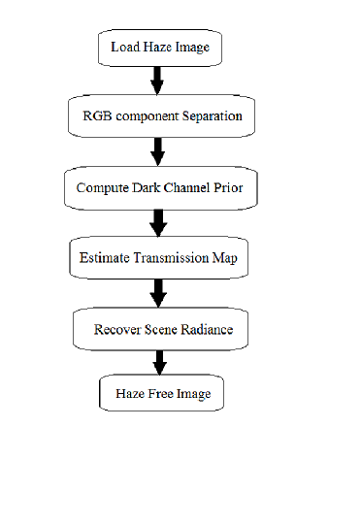

**DARK CHANNEL PRIOR CALCULATION:**

As per described in the paper with the same name; the dark channel prior is calculated as follows:

The sequence of steps is controlled by the following equation

http://latex.codecogs.com/gif.latex?I%5E%7Bdark%7D%28x%2C%20y%29%20%3D%20%5Cmin_%7Bc%20%5Cin%20%5C%7Br%2C%20g%2C%20b%5C%7D%7D%5Cleft%28%5Cmin_%7B%28x%27%2C%20y%27%29%20%5Cin%20%5COmega%28x%2Cy%29%7D%20I%5E%7Bc%7D%28x%27%2Cy%27%29%5Cright%29

Which is the dark channel for each block

Where,

where

* Ic (x',y') denotes the intensity at a pixel location (x',y') in color channel c (one of Red, Green, or Blue color channel)
* Ω (x,y) denotes the neighborhood of the pixel location (x',y').

Further on the basic threshold of the image is calculated using the average of the least ten values in the dark channel. Range defines the upper and lower bound of the dark channel which is used to control the pixels which actually are present in the dark channel while removing the haze. The average parameter is also helpful in replacing the foggy parts with the counter dark channel pixel’s average.

This only solves 1/3rd of the problem. As the range defines the first gradient strip over that dark channel and only solves the pixels which are bounded by the average threshold and lie within that dark channel’s range.

To solve it for the rest of the pixels where the major details start to fail and the visibility is low (i.e. where a greater amount of haze is present), we need to define another gradient strips which takes average as the low value and the brightest pixel of the channel as upper bound.

Repeating this process and increasing the gradient strips sharpens out the details in a fine way.

There are a few output samples that I ran the code on using the single gradient strip:

**Output:**

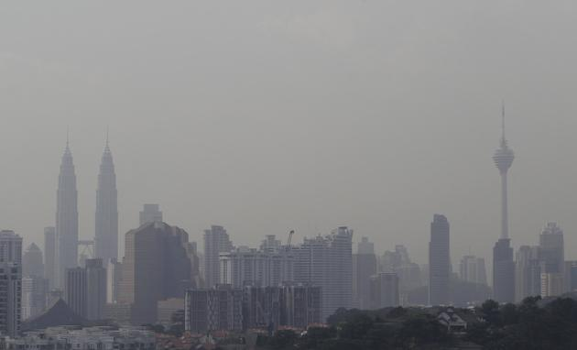

HazyImage

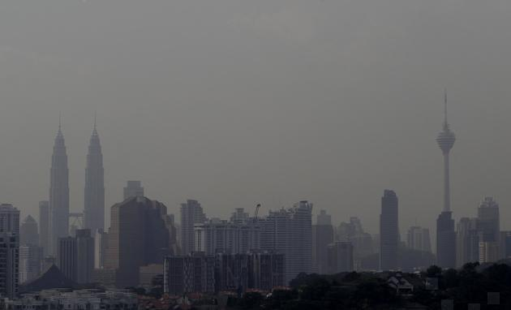

Haze Removal Using single gradient strip Dark Channel

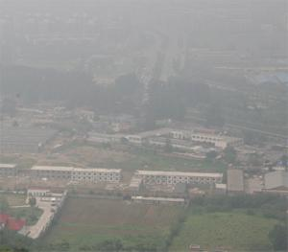

HazyImage

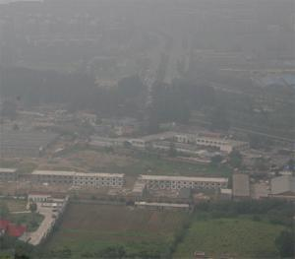

Haze Removal Using single gradient strip Dark Channel

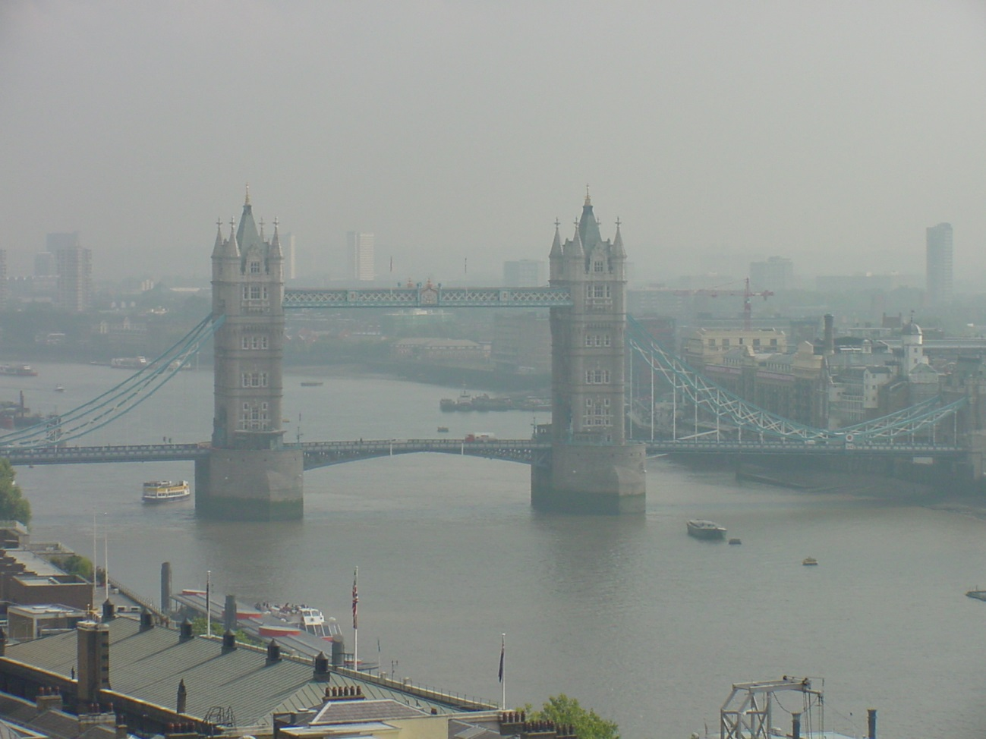

HazyImage

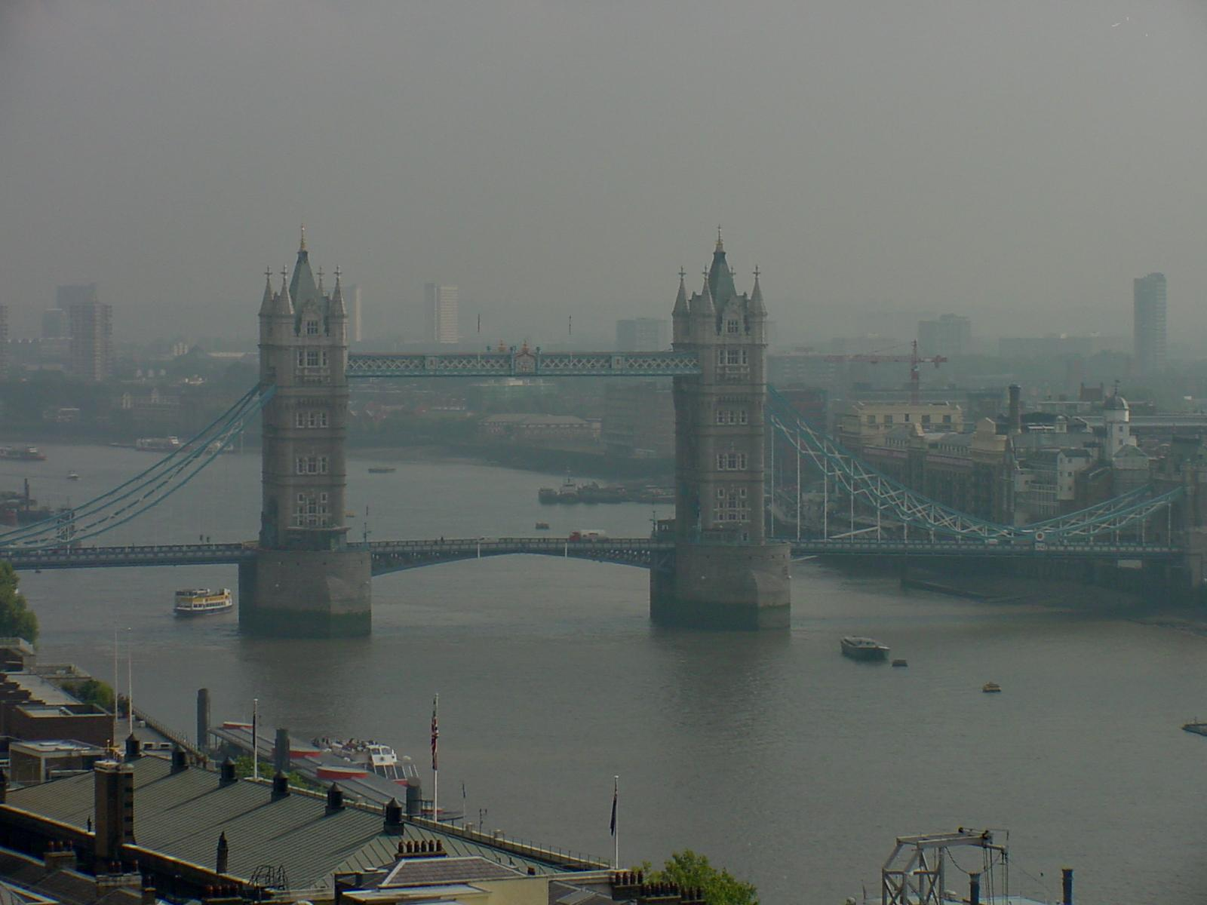

Haze Removal Using single gradient strip Dark Channel

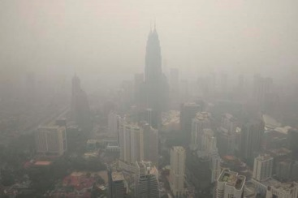

HazyImage

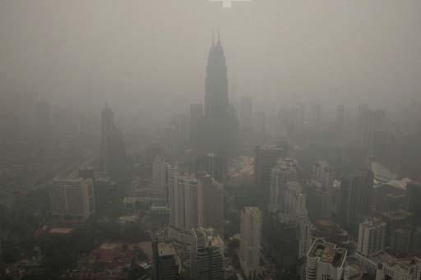

Haze Removal Using single gradient strip Dark Channel

**DARK CHANNELS**

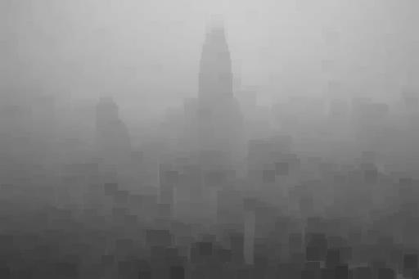

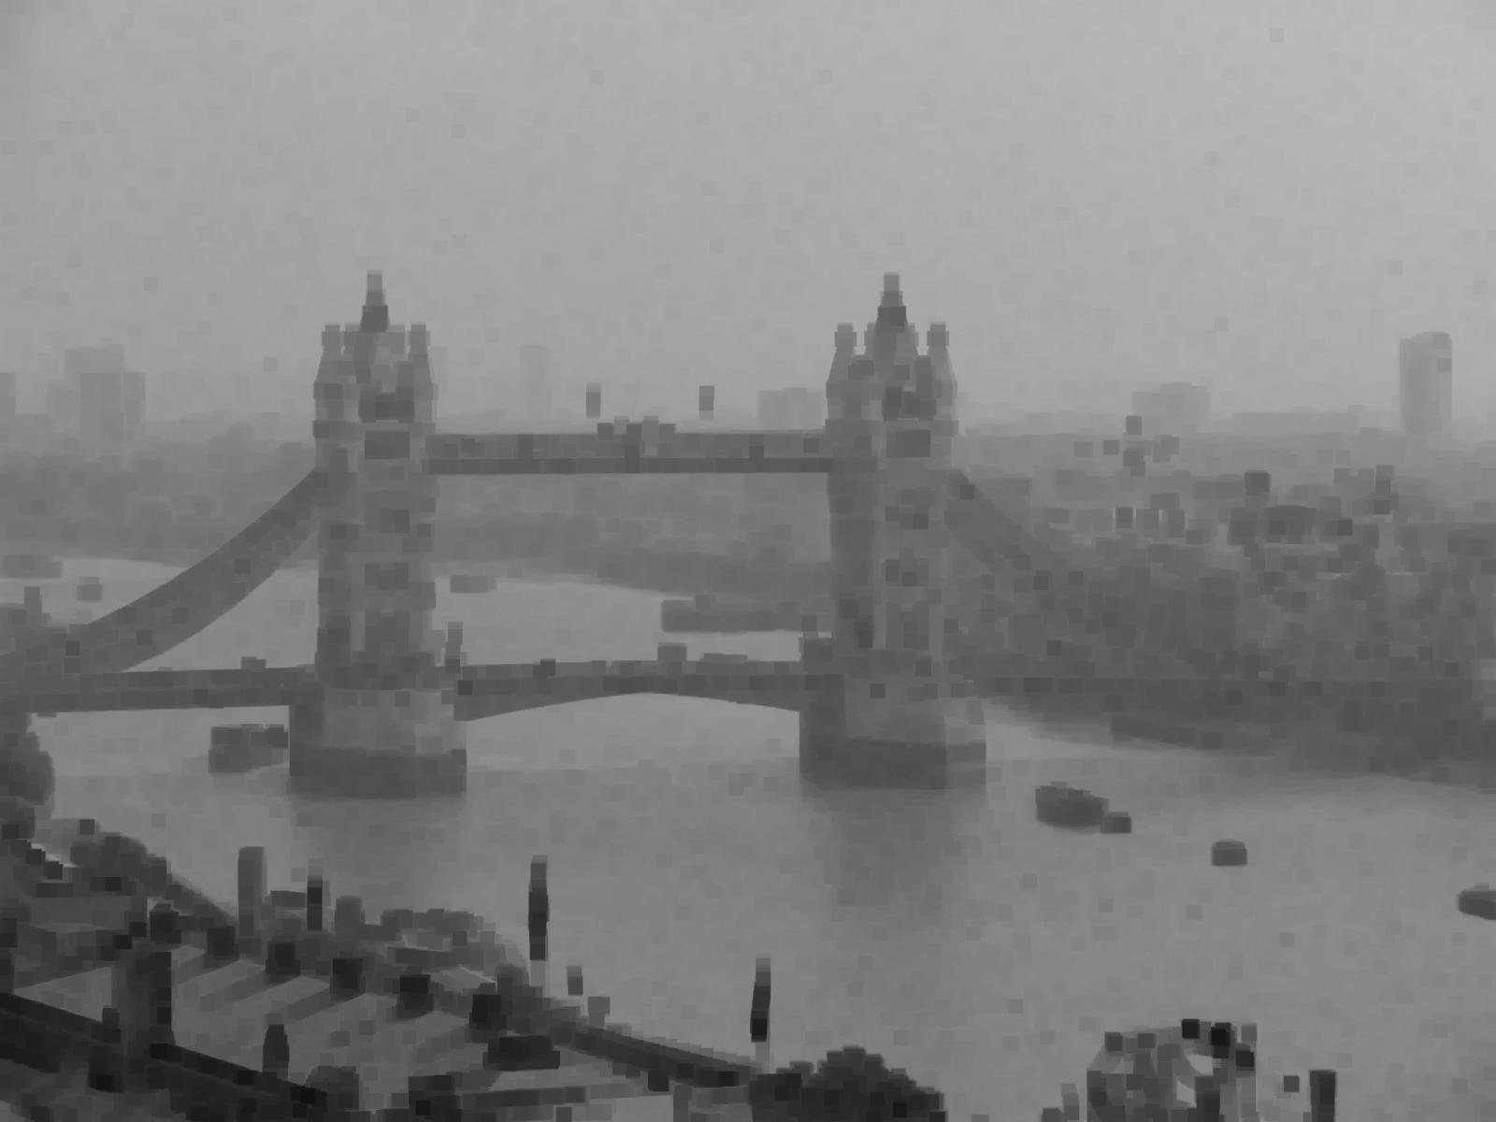

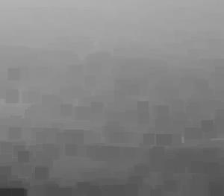

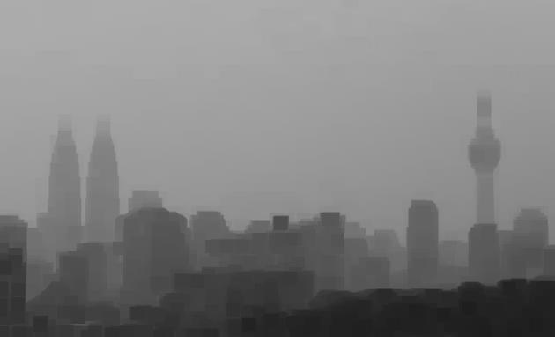

**REFERENCES:**

* [*https://solidparallel.wordpress.com/2012/05/08/computer-vision-final-project-single-image-haze-removal/*](https://solidparallel.wordpress.com/2012/05/08/computer-vision-final-project-single-image-haze-removal/)
* [*https://www.youtube.com/watch?v=DwagC2ZI17Y*](https://www.youtube.com/watch?v=DwagC2ZI17Y)